CO-1AT2

COMPUTER VISION CONCEPT MAP

Name:S.Varsha Reddy
Registration No:192572177
Code:ITA0510

1. Construct a comprehensive and well-organized concept map that accurately identifies all key
concepts from literature involved in the pipeline from real-world scene capture to digital image
representation, establishes clear and meaningful relationships among intermediate
transformations and dependencies, integrates insights from multiple studies, and presents the
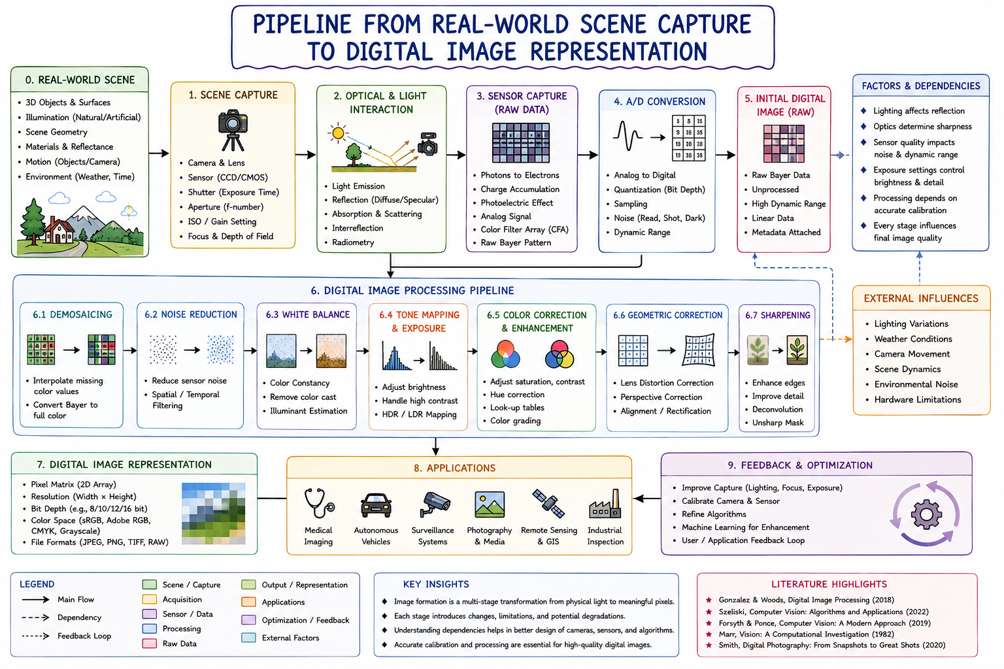
information in a clear and visually structured manner.
2. Develop a hierarchically structured concept map that identifies major stages of visual data
handling in a Computer Vision system, clearly illustrates logical relationships and contributions
of each stage toward generating meaningful outputs, incorporates relevant literature
connections, and ensures clarity and readability.

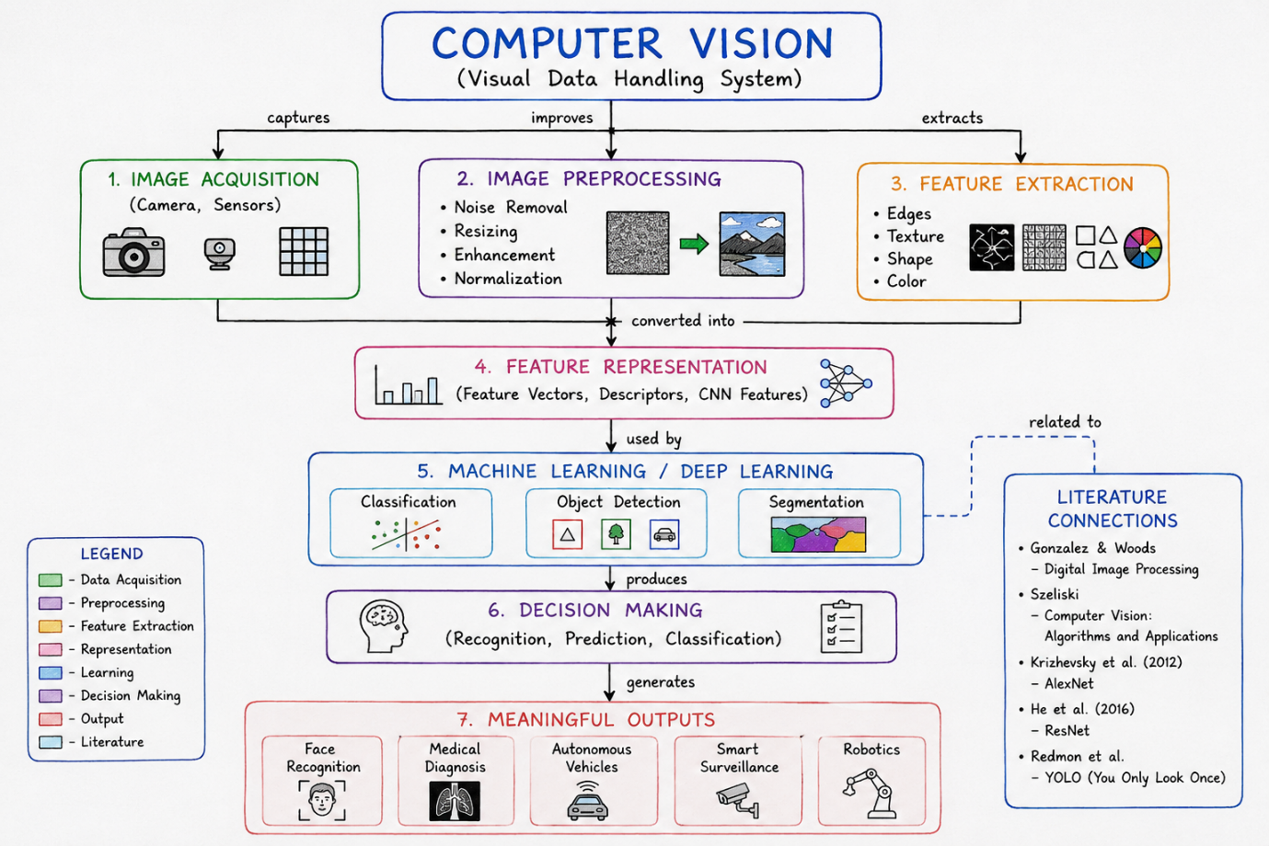

3. Create a detailed concept map that accurately identifies concepts related to image resolution
and intensity levels, establishes clear cause–effect relationships with image quality and usability,
integrates supporting evidence from literature, and presents the concepts in a logically
organized and visually clear format.

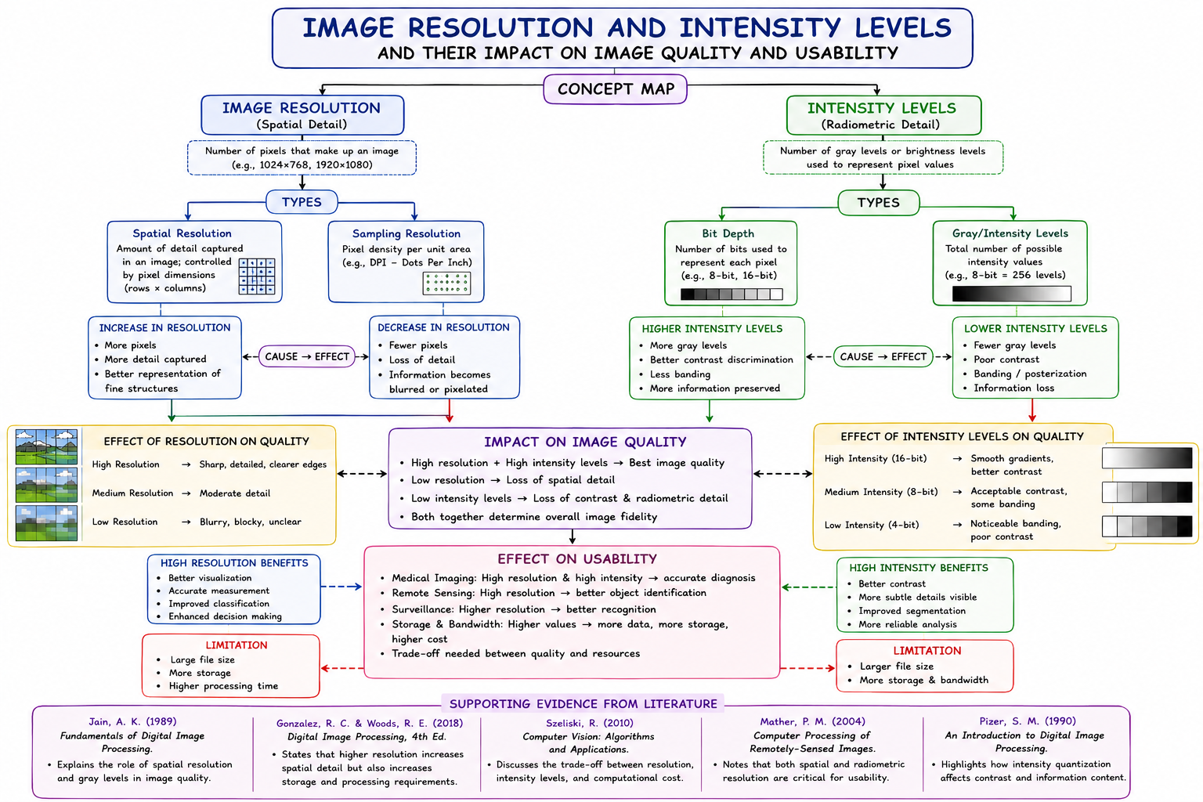

4. Design an analytically organized concept map that identifies key factors in image acquisition
conditions, clearly links them to downstream processing and application performance through
meaningful relationships, integrates findings from relevant studies, and ensures a well-
structured and easy-to-interpret presentation.

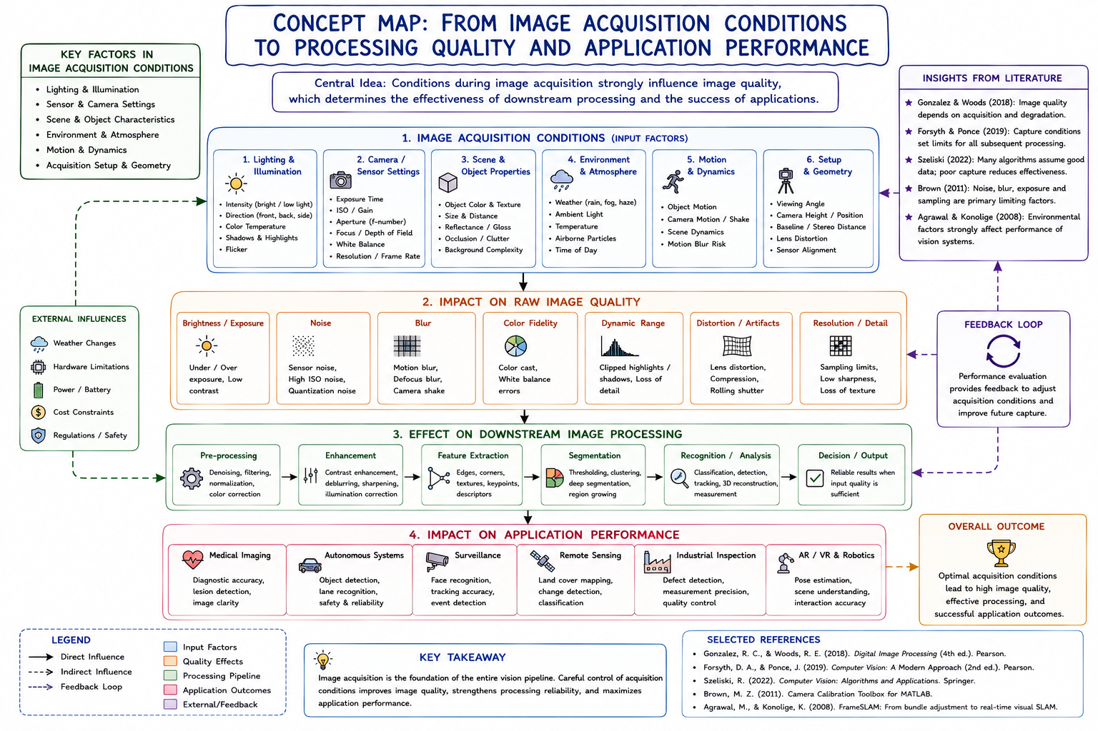

5. Construct an original and logically structured concept map that identifies system capabilities and
their influence on the selection and effectiveness of vision-based applications, establishes clear
interconnections, integrates multiple literature perspectives, and maintains high clarity and
visual organization.
